NATIONAL COLLEGE OF ENGINEERING

(Affiliated to Tribhuvan University) Talchhikhel, Lalitpur



A MINOR PROJECT PROPOSAL ON

## “English To Sign Language Translation Using Python”

Submitted by:

Ranjit Adhikari NCE078BCT031

Sarishma Neupane NCE078BCT038

Sujit Adhikari NCE078BCT044

Prayash Niraula NCE078BCT029

Submitted to

Department of Computer and Electronics Engineering Asar, 2081

# TABLE OF CONTENTS

1. TABLE OF CONTENTS ii

LISTOF FIGURES iii

LIST OF ABBREVIATIONS iv

* 1. INTRODUCTION 1
  2. BACKGROUND 1
  3. PROBLEM STATEMENT 2
  4. AIM AND OBJECTIVE 3
  5. SCOPE 4

1. LITERATURE REVIEW 5
2. METHODOLOGY 8
   1. SYSTEM BLOCK DIAGRAM 8
   2. TOOLS AND TECHNOLOGY TO BE USED 14
3. EPILOGUE 15
   1. EXPECTED OUTPUT 15
   2. GANTT CHART 16

REFERENCES 17

# LIST OF FIGURES

Figure 1: System block diagram 8

Figure 2: Porter Stemming Algorithm 11

Figure 3: Gantt chart 16

# LIST OF ABBREVIATIONS

|  |  |
| --- | --- |
| AI | Artificial Intelligence |
| CNN | Convolutional Neural Network |
| GHz | Gigahertz |
| GPU | Graphics Processing Unit |
| NLTK | Natural Language Tool Kit |
| NLP | Natural Language Processing |
| PC | Personal Computer |
| POS | Part-of-Speech |
| LSTM | Long Short-Term Memory |

# INTRODUCTION

# BACKGROUND

Individuals with hard-to-hear face significant communication barriers, as spoken languages are not understandable to them. For people with hearing impairment, sign language provides a platform for coping with society. However, there is some hindrance in the existing system, so that there is lack of effectiveness in existing “Sign Language Translators”. To address these challenges, this project proposal aims to advance the field of AI-based sign language detection and transforms the voice or English inputs in the form of Sign language animation or video.

A key component of this project is the development of a comprehensive dataset of sign language gestures. This dataset will be essential for training and evaluating AI models. It will feature annotated sign language, covering a broad spectrum of gestures and expressions. This thorough curation will allow the models to learn and accurately recognize sign language patterns with a high degree of precision.

The proposed project will employ Natural Language Processing (NLP) to interpret the text while to interpret the voice the project will employ PyAudio. For quicker inference, the proposed project will implement an effective Graphics Processing Unit (GPUs). Various work will take place and required efforts will be drawn for developing the system, ensuring the least possible delay and enabling real-time interpretation of sign language.

By drawing the required effort and placing the work properly, the proposed system aims to bring noticeable change in society. The main motive of this project is to reduce the communication gap between industry and individuals with hearing impairments.

The goal is to empower individuals to express themselves effectively and engage fully in society, promoting inclusivity and equal opportunities. This project proposal presents an innovative and technologically advanced solution to overcome communication barriers faced by people with hearing impairments. It aims to significantly advance sign language detection systems and improve communication accessibility.

# PROBLEM STATEMENT

* + - Communication between normal people and the hearing and speaking impaired is challenging due to lack of system implemented.
    - Existing sign language recognition systems have limitations:
      * Low accuracy.
      * Difficult interfaces.
    - No sign language recognition system exists in Industry.

# AIM AND OBJECTIVE

## Aim: -

* + - The aim of this project is to develop an AI-based English to sign language translation system to enhance communication accessibility for individuals with hearing impairments.

## Objectives: -

To comprehend the daily challenges encountered by individuals with disabilities and to devise a solution that is:

* Cost-effective
* Widely adaptable
* User-friendly
* Understanding the needs of the impaired community, we aim to create a solution that makes a meaningful impact.
* To enhance the physical and mental well-being of people with disabilities, ultimately improving their overall quality of life.
* To provide a Universal Sign Language Recognition System.

# SCOPE

The project will impact various sectors, including education, healthcare and employment by enhancing learning tools for deaf students, improving communication between healthcare providers and deaf patients and providing training programs in the workplace. It will also advance accessibility and inclusivity in digital content, offering subtitles and real-time translations in sign language. Public services, customer service, retail and e-commerce will benefit from accessible websites and communication tools.

Additionally, it will promote social integration, bridge communication gaps and raise awareness about the needs and capabilities of the deaf and hard-of-hearing community, fostering a more inclusive society. It will serve a pivotal role in the commercial sectors as it will help immensely in the active communication between the service providers and the heard-of hearing community. The project is finally seen to help the deaf people for giving a sense of inclusivity in the society as a better understanding is maintained.

The project will help in the medical sectors for the understanding between medical professionals and the deaf people. The lack of effective communication has created a problem in the nursing sector and understanding the needs which are urgently required, especially in medical sectors, and thus the project will help bridge the gap.

# LITERATURE REVIEW

The article “Sign language Recognition Using machine learning”, by Sneha Prabhu, Sriraksha Shetty, Sushmitha P Suvarna, VindyaSanil, Dr.Jagadisha N,published in 2022, explores how sign languages can be recognized and translates it into text. The study looks at how the photo frames of sign language are pre-processed and classified using CNN. The article shows how the model is constructed from these pre-processed and classified photos and trained to get the final output. The study shows how the proposed website recognizes sign language and translates it into text with 93.27% accuracy with less computational time [1].

The article “Speech To Sign Language Translator for Hearing Impaired”, by Ezhumalai P, Raj Kumar M,Rahul A S, Vimalanathan V, Yuvaraj A, published in 2021, focuses in the topic of taking speech as input and translating them into sign language. This system was developed for Indian sign language translation. The system was designed in a way that if the word the user gives in the input as form of audio is not found in local system, the system will search for the word in a sign language repository named ‘‘Indian sign language portal’’. The system used web scrapping for playing the corresponding sign language video sequence from Indian sign language portal. The execution time of system was 28.94 seconds to convert speech to sign language.[2]

The article "Sign Language Detection System" by Dr. Pallavi Chaudhari, Pranay Pathrabe, Umang Ghatbandhe, Sangita Mondal, and Sejal Parmar introduces a real- time approach for recognizing sign language gestures using convolutional neural networks (CNNs). This system is designed to facilitate communication between deaf and mute individuals and the general public by enabling the understanding and interpretation of sign language. The authors detail the architecture of their CNN model, which involves processing the hand image through a filter and then applying a classifier to predict the gesture class. Impressively, the model achieves a 98% accuracy rate for recognizing the alphabet letters A-Z in sign language. Beyond gesture detection, the

article explores the creation of a communication system for deaf individuals. This system translates audio messages into corresponding sign language using predefined American Sign Language images and videos. By incorporating this feature, the authors propose a user-friendly human-computer interface that allows for seamless interaction between deaf and hearing individuals. [3]

The article "Real Time Sign Language Recognition System for Hearing and Speech Impaired People”by Tanmay Petkar, Tanay Patil, Ashwini Wadhankar, Vaishnavi Chandore , Vaishnavi Umate , Dhanshri Hingnekar, published in 2022, proposed a system which works in both ways: Sign-language to Text conversion and Text to Sign- language Conversion. This proposed system created their own dataset by recording and saving gestures through a laptop camera or webcam with the help of OpenCV. This system used TensorFlow which helped it in achieving accuracy of 90% and predicting the text accurately. Beside this, the system created an Avatar using Blender 3D tool and animated the equivalent gestures for the alphabets and words. In this work, they propose a new posture-guided pooling strategy to extract features from 3D convolutional neutral networks in the context of world-class sign language recognition.This system uses NLTK to translate the text input given by the user into its equivalent gestures. JavaScript Web Speech API was used by this system to generate output text from the input audio signal.[4]

The article titled "Sign Language Recognition and Translation: A Multidisciplinary Approach from the Field of Artificial Intelligence" by Becky Sue Parton examines the use of artificial intelligence (AI) in sign language recognition and translation. The author introduces a cross-disciplinary approach that merges AI techniques with insights from sign language linguistics. The article underscores the difficulties encountered by the deaf and hard-of-hearing community in communicating with non-sign language users and stresses the necessity of creating precise and effective sign language recognition and translation systems. It reviews the shortcomings of conventional methods and contends that AI can significantly address these issues.[5]

The paper titled "Deep Sign: Sign Language Detection and Recognition Using Deep Learning" introduces a system that employs deep learning methods to identify and interpret sign language gestures. The primary aim is to diminish communication obstacles for individuals with speech or hearing impairments. The researchers developed a model utilizing LSTM and GRU, two variants of recurrent neural networks, to recognize signs from video frames of Indian Sign Language. They constructed a custom dataset named IISL2020, comprising 11 frequently used signs. The proposed model attained an impressive accuracy rate of approximately 97% for recognizing these 11 signs. The system functions by capturing video of a person's hand gestures, processing it, and employing the deep learning model to predict the associated words. This facilitates communication between individuals who do not know sign language and those with speech or hearing impairments. The paper also reviews related research in the domain of sign language recognition, covering various techniques and models from previous studies. It underscores the significance of sign language as a visual mode of communication and the necessity for precise and efficient recognition systems. Overall, the research paper advocates for a deep learning-based approach to sign language detection and recognition, aiming to bridge the communication gap between individuals with speech or hearing impairments and those unfamiliar with sign language.[6]

# METHODOLOGY

* 1. **SYSTEM BLOCK DIAGRAM**

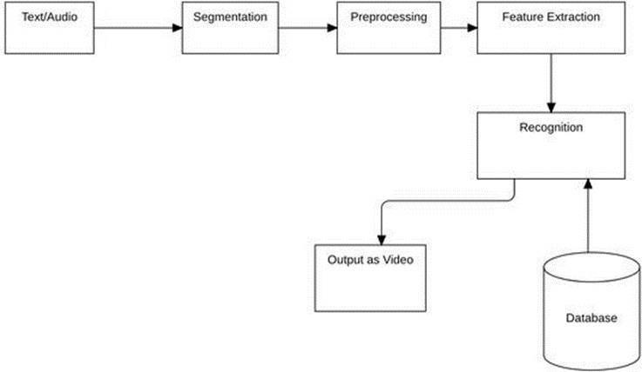

Figure 1: System block diagram

## Text/Audio:

The text or audio is fed as input to the proposed system. This is the first step for executing the process of the system. The user either inputs the text or provides the speech expecting the sign language video as outcome.

## Segmentation:

0nce the user gives the text or when the text is recognized from the voice input, the system performs segmentation to classify the words and the letters from the obtained text. This step helps to isolate letters and extract the corresponding sign language to be displayed through the video. Various text segmentation techniques can be used to separate the letters from the given text.

## Preprocessing:

The segmented text undergoes various pre-processing techniques to isolate the letters and word from the whole text. The text generated from the voice input is ensured to match with the voice’s essence. Overall, the preprocessing step makes sure that the further steps operate on clean and clear data.

## Feature Extraction:

Next, features relevant to text recognition are extracted from the preprocessed text. These features capture important information about the text's position and spatial relationships with corresponding sign gestures. Advanced algorithms map these features to specific sign language gestures, ensuring accurate representation. Finally, the system displays the corresponding signs in real- time, providing effective communication for individuals with hearing impairments.

## Recognition:

The extracted features are then fed into the NLP algorithm and converted into tokens using NLTK (Natural Language Tool Kit). POS tags are produced from the tokens and the tags are used to match the exact sign gesture from the dataset. The obtained sign gesture is read, and corresponding animation is played until the whole given sentence is interpreted by the animation. The user is able to replay or pause the animation as per their need which helps in better and efficient communication with the person with hearing impairment.

## Output as Video:

The recognized text or letters are displayed along with the sign language gestures simultaneously one after the other. For example, if the user input is “Apple”, the system breaks down the word to letters as “A”, “P”, “P”, “L”, “E” and displays each letter as their sign language while displaying the corresponding letters simultaneously.

## Algorithm to be used:

**Porter stemming algorithm**

Porter Stemming algorithm provides a basic approach to conflation that may work well in practice. Natural Language Processing (NLP) helps the computer to understand the human natural language. Porter Stemming is one of the Natural Language Processing techniques. It is the famous stemming algorithm proposed in 1980. Porter Stemmer algorithm is known for its speed and ease. It is mainly used for data mining and to retrieve information. It produces better results than any other stemming algorithms. It has less error rate. The system removes the morphological and in flexional endings of the English words. The system uses Porter stemming Algorithm to remove the commonly used suffixes and prefixes of the words and find the root word or original word. For example, the Porter stemming algorithm reduces the words “agrees”, “agreeable”, “agreement” to the root word “agree”. Because of this stemming, we can reduce the time taken for searching the sign language for the given word.

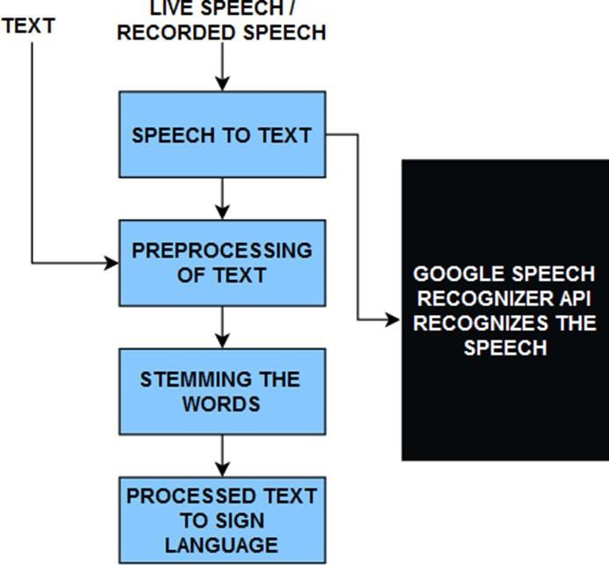

Figure 2: Porter Stemming Algorithm

## Functional Requirements

* + - System should be able to understand the text or audio given by the user.
    - System should be able to interpret the text and recognize audio without neglecting its meaning to given effective video output illustrating sign language.

## Non-Functional Requirements

* + - Time of response must not exceed than 5 seconds.
    - The web application developed should be built in a user-friendly interface.

## Feasibility study

1. **Technical feasibility**

The current system supports all the necessary operations for this project. It utilizes React for the front-end and Django for the back-end. This setup ensures that outputs are produced within the specified time frame and that the response time is satisfactory. Users can access the product through any web browser.

## Operational Feasibility

This project is simple to implement and do not require any sort of additional practice.

## Schedule Feasibility

All the features of the project can be complete within the given time. This project can be finished within five months and the time schedule is shown in Gantt chart.

## Economical Feasibility

The cost required for this project lies within the budget. There is no need of additional hardware or software components which will lead this project economically feasible.

The cost required for this project lies within the budget. There is no need of additional hardware or software components which will lead this project economically feasible.

## Legal Feasibility

This project follows the guidelines of concerned authorities and doesn’t violate any socio-economics sentiment. It can be applicable worldwide.

# TOOLS AND TECHNOLOGY TO BE USED

## Hardware requirements:

For admin: Processor: 2 GHz or more RAM: 4 GB

GPU

For users: Mobile or PC with microphone.

## Software requirements:

For development:

Application software: Visual studio, Browser (Google chrome, Brave) Languages and frameworks: Python, Django.

For users: Browser

# EPILOGUE

* 1. **EXPECTED OUTPUT**

The expected output of the English to Sign language translation system would be the translation of text in English (either manually typed or through a voice command) into recognized sign language gesture. This means that when a user inputs a text, then the text is processed through NLP algorithm that will break and classify the given text into words and letters to provide Sign language video to the user. If the user chooses voice as input, then the system processes the voice by speech recognition using Google Speech API and transcribes the voice input into text format using python library “PyAudio”. Finally, the system will map the recognized text or audio to its corresponding Sign language animations.

# GANTT CHART

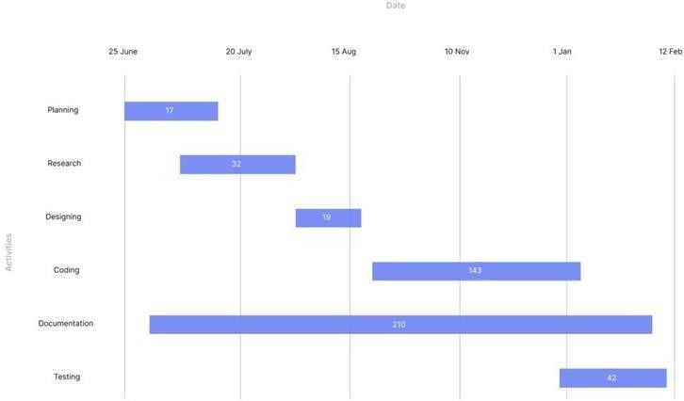

Figure 3: Gantt chart

A Gantt chart below shows the dates and important events that were all a huge part of the timeline of the proposal. However, the Gantt chart for the system development to completion of the project will be combined with a proposal in another document, i.e. the final report of the project.

# REFERENCES

1. S. Prabhu, S. Shetty, S. P. Suvarna, V. Sanil, and J. N., "Sign language Recognition Using machine learning," 2022.
2. E. P., R. K. M., R. A. S., V. V., and Y. A., "Speech To Sign Language Translator For Hearing Impaired," 2021.
3. P. Chaudhari, P. Pathrabe, U. Ghatbandhe, S. Mondal, and S. Parmar, "Sign Language Detection System," 2022.
4. T. Petkar, T. Patil, A. Wadhankar, V. Chandore, V. Umate, and D. Hingnekar, "Real Time Sign Language Recognition System for Hearing and Speech Impaired People," 2022.
5. B. S. Parton, "Sign Language Recognition and Translation: A Multidisciplinary Approach from the Field of Artificial Intelligence," 2022.
6. "Deep Sign: Sign Language Detection and Recognition Using Deep Learning," 2022.